ACKNOWLEDGEMENT RECEIPT

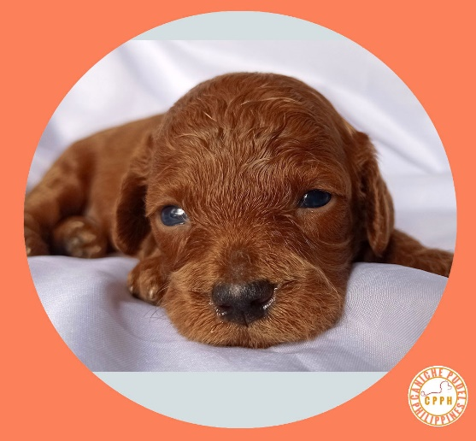
Date : 04 January 2023
SUBJECT: “ RESERVATION FEE / DOWN PAYMENT”
for the purchase of One MALE Puppy
with a PCCI Birth Certificate.
Ten thousand Pesos (PHP10,000)
AUTUMN OF CANICHE PUDEL

BUYER : Reggie Brillantes
Address :
Email :
Cell # :

That the acceptance of SELLER of said “RESERVATION FEE / DOWNPAYMENT” are subject to the following condition:
- BUYER has seen/inspected the PUPPY and decided to buy/purchase the PUPPY on or before 04 February 2023.
- BUYER has agreed to buy/purchase the PUPPY for the value of Twenty-one thousand, Philippine currency (PHP21,000), outright cash payment, on or before 04 February 2023.
- RESERVATION FEE / DOWNPAYMENT shall be deducted “IN FULL” from the agreed purchase/acquisition value, as stated first above, at the time of outright cash payment purchase/acquisition on or before 04 February 2023.
- RESERVATION FEE / DOWNPAYMENT shall be forfeited “IN FULL” in favor of SELLER for the failure of BUYER to buy/purchase and pay IN FULL the PUPPY on or before 04 February 2023.
- RESERVATION FEE / DOWNPAYMENT Guarantees BUYER the exclusive right to purchase the PUPPY on or before 04 February 2023.
- Should anything happen to the PUPPY (Death / Sickness- GOD FORBID) on or before the scheduled release date of 04 February 2023, the RESERVATION FEE / DOWNPAYMENT shall be REFUNDED IN FULL by SELLER to BUYER.
SELLER hereby warrants that the corresponding PCCI Birth Certificate, and Vet Vaccination Record for 1 vaccine of the PUPPY will be given/released to BUYER at the time of full payment of the PUPPY on or before 04 February 2023.

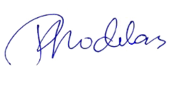

SELLER : Rodolfo Rodelas
+63 995 416 8113
CANICHE PUDEL PHILIPPINES
admin@canichepudelph.com
https://www.canichepudelph.com

