ACKNOWLEDGEMENT RECEIPT

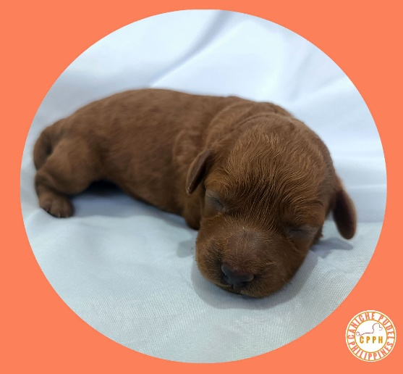
Date : 19 June 2023
SUBJECT: “ RESERVATION FEE / DOWN PAYMENT”
for the purchase of One FEMALE Puppy
with a PCCI Paper and Microchip.
Five thousand Pesos (PHP 5,000)
AALIYAH OF CANICHE PUDEL

BUYER : Ma’am Jane
Address :
Email :
Cell # :

1-A. The buyer has seen the PUPPY and decided whether or not to buy it on or before 11 July 2023. If not, the initial reservation fee stated above has been refunded by the seller to the buyer.
2-A. After 11 July 2023, the Buyer agrees to the following conditions:

- BUYER has seen/inspected the PUPPY and decided to buy/purchase the PUPPY on or before 05 August 2023.
- BUYER has agreed to buy/purchase the PUPPY for the value of Twenty-six thousand, Philippine currency (PHP26,000), outright cash payment, on or before 05 August 2023.
- RESERVATION FEE / DOWNPAYMENT shall be deducted “IN FULL” from the agreed purchase/acquisition value, as stated first above, at the time of outright cash payment purchase/acquisition on or before 05 August 2023.
- RESERVATION FEE / DOWNPAYMENT shall be forfeited “IN FULL” in favor of SELLER for the failure of BUYER to buy/purchase and pay IN FULL the PUPPY on or before 05 August 2023.
- RESERVATION FEE / DOWNPAYMENT Guarantees BUYER the exclusive right to purchase the PUPPY on or before 05 August 2023.
- Should anything happen to the PUPPY (Death / Sickness- GOD FORBID) on or before the scheduled release date of 05 August 2023, the RESERVATION FEE / DOWNPAYMENT shall be REFUNDED IN FULL by SELLER to BUYER.
SELLER hereby warrants that the corresponding PCCI Paper with Microchip, and Vet Vaccination Record for 1 vaccine of the PUPPY will be given/released to BUYER at the time of full payment of the PUPPY on or before 05 August 2023.
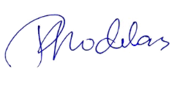

SELLER : Rodolfo Rodelas
+63 995 416 8113
CANICHE PUDEL PHILIPPINES
admin@canichepudelph.com
https://www.canichepudelph.com

